📁 4. Twin-Shaft Shredder Series
Featuring a dual-shaft open feed design, suitable for processing industrial waste, boxed documents, plastic barrels, circuit boards, and other rigid materials.
Convenient for integration with upstream and downstream equipment in user production lines.
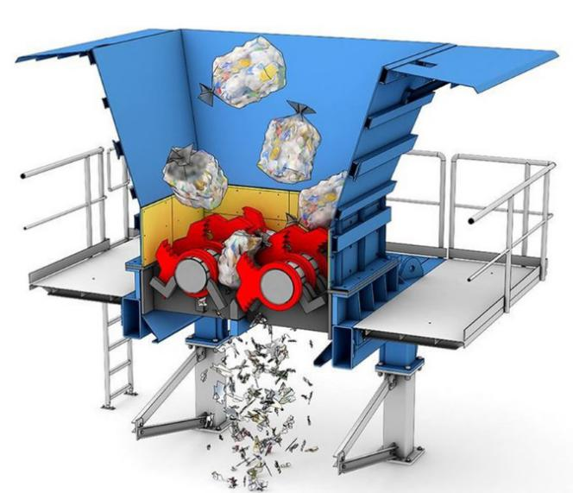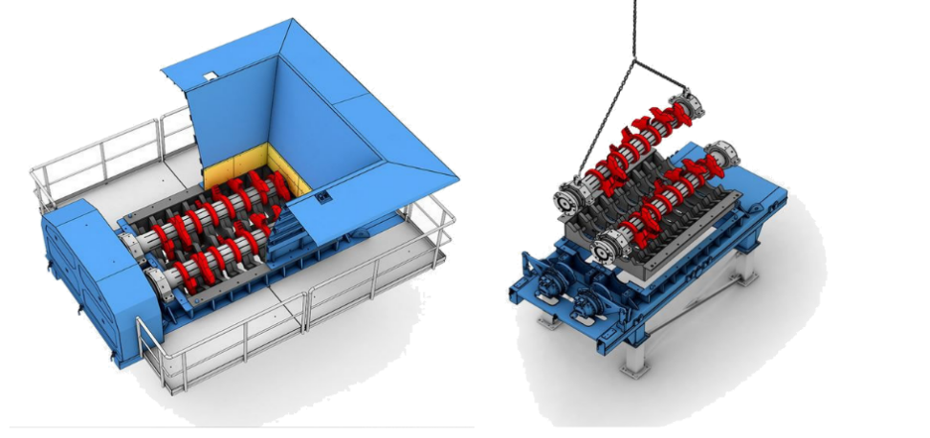
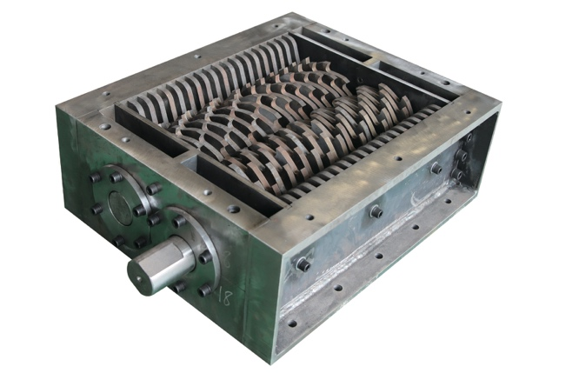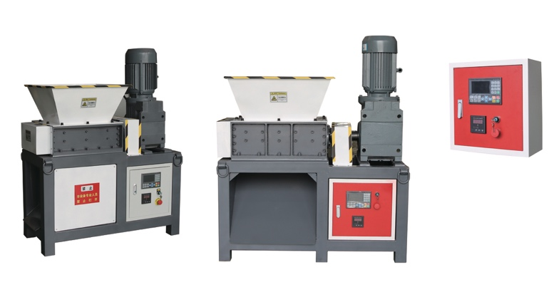

📁 4. 双轴撕碎机系列（Twin-Shaft Shredder Series）
采用双轴开放式大入口设计，适用于处理工业废料、整箱文件、塑料桶、线路板等各类硬质物料，便于与用户生产线前端和后端处理设备无缝对接。

➕ Custom Cases更多定制案例
🖼️Front View | 📥Feeding Inlet | 🆔Model |  | 💰Price (USD)

📄 YD-SSJ Series Twin-Shaft Shredder
Small Twin Shaft Shredders Selection Table v3
🆔Model | ⚡Motor | ⚙️Gearbox | 📏Blade Spec. | 🔢Blades Num. | 📥Hopper Size (mm) | 📏 L×W×H  (mm) | 💰Price (RMB) | 💰Price (USD)
🆔型号 | ⚡电机 | ⚙️减速机 | 📏刀片规格 | 🔢刀片数量 | 📥料斗尺寸 | 📏外形尺寸 | 💰人民币价 | 💰美元报价
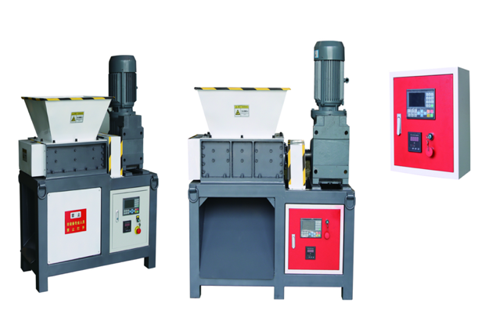
Single Motor Model单电机机型
YD-SSJ300SK | 3KW-4, 1 unit | k77,1 unit | Φ180*10 | 29 | 500*500*300 | 1100*650*1350 | 30500 | 4358
YD-SSJ400SK | 5.5KW-4,1 unit | K87,1 unit | φ180*15 | 27 | 500*600*300 | 1250*650*1450 | 41800 | 5972
YD-SSJ400SK | 5.5KW-4,1 unit | K87,1 unit | φ180*10 | 40 | 500*600*300 | 1250*650*1450 | 43800 | 6258
YD-SSJ500SK | 7.5KW-4,1 unit | K97,1 unit | Φ200*20 | 24 | 600*700*400 | 1400*750*1600 | 57300 | 8186
YD-SSJ600SK | 7.5KW-4,1 unit | K107,1 unit | Φ220*25 | 24 | 700*800*500 | 1600*900*1750 | 72500 | 10358
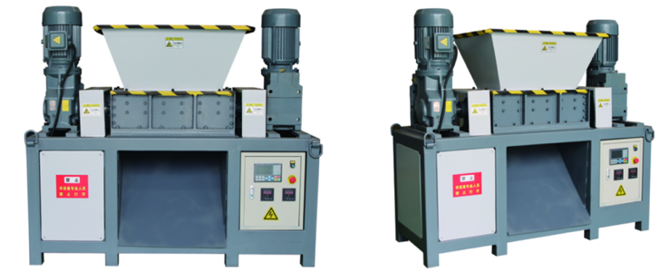
Dual Motor Model双电机机型
YD-SSJ400DK | 5.5KW-4, 2 unit | K87,2 unit | Φ180*15 | 27 | 500*600*300 | 1600*650*1450 | 62000 | 8858
YD-SSJ400DK | 5.5KW-4, 2 unit | K87,2 unit | Φ180*10 | 40 | 500*600*300 | 1600*650*1450 | 59900 | 8558
YD-SSJ500DK | 7.5KW-4,2 unit | K97,2 unit | Φ200*20 | 24 | 600*700*400 | 1900*750*1600 | 75400 | 10772
YD-SSJ600DK | 7.5KW-4, 2 unit | K107,2 unit | Φ220*25 | 24 | 700*800*500 | 2100*750*1800 | 98600 | 14086
🧩Custom Cases & Our Advantages 我们的优势
We provide on-site customized solutions based on your specific needs. With extensive experience in dual-shaft shredding applications, YUEDU Shredders is committed to efficient and honest communication to deliver precisely matched products and services. 我们根据用户的实际需求提供现场定制解决方案。越都公司在双轴撕碎机的领域拥有丰富的应用经验。我们期待与您进行高效、坦诚的沟通，提供精准匹配的产品与服务。

